**Introduction to CSS:** CSS stands for Cascading Style Sheets. It is a style sheet language used for describing the look and formatting of a document written in HTML or XML. It provides more control over the appearance of your web content.

**CSS3 Selectors:** CSS3 selectors are patterns used to select the elements you want to style. For example, the p selector selects all <p> elements:

**Pseudo Elements:** Pseudo-elements are used to style specific parts of an element. For example, ::first-line selects the first line of an element:

**Pseudo Classes:** Pseudo-classes are used to define a special state of an element. For example, :hover applies a style when the user hovers over an element:

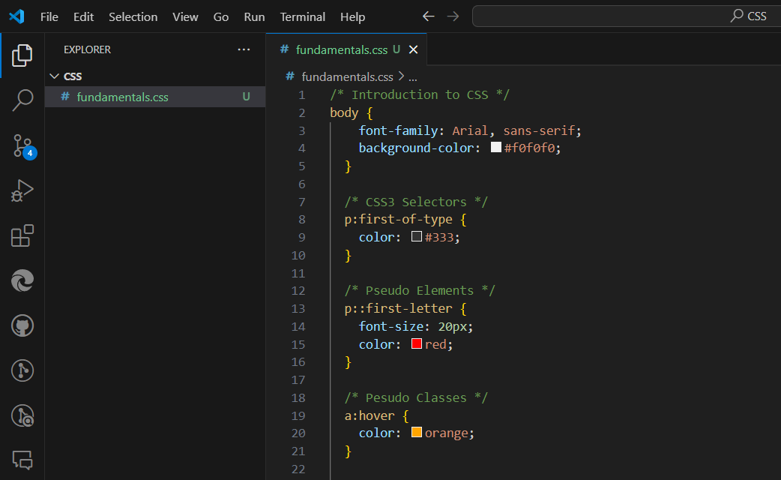



**Introduction to Stylesheets:** A stylesheet contains a set of rules that specify how to style an HTML document. It can be internal (within the <style> tag), external (linked with the <link> tag), or inline (within the style attribute of an HTML tag).

**CSS Fonts:** The CSS font property is a shorthand property for font-style, font-variant, font-weight, font-size, line-height, and font-family. Alternatively, these properties can be set individually.

**CSS Text:** CSS has a variety of properties to style text. For example, text-align sets the horizontal alignment of text:

**CSS Box Model:** The CSS box model is a box that wraps around every HTML element. It consists of: margins, borders, padding, and the actual content.

**CSS Colors:** CSS colors can be set by name, hexadecimal value, RGB value, RGBA

**CSS Background:** The CSS background property is a shorthand property for setting the individual background properties (i.e., background-color, background-image, background-repeat, background-attachment, background-position) in a single place.

**CSS Gradients:** CSS gradients let you display smooth transitions between two or more specified colors. CSS supports linear and radial gradients.

: linear-gradient(to right, red , yellow);

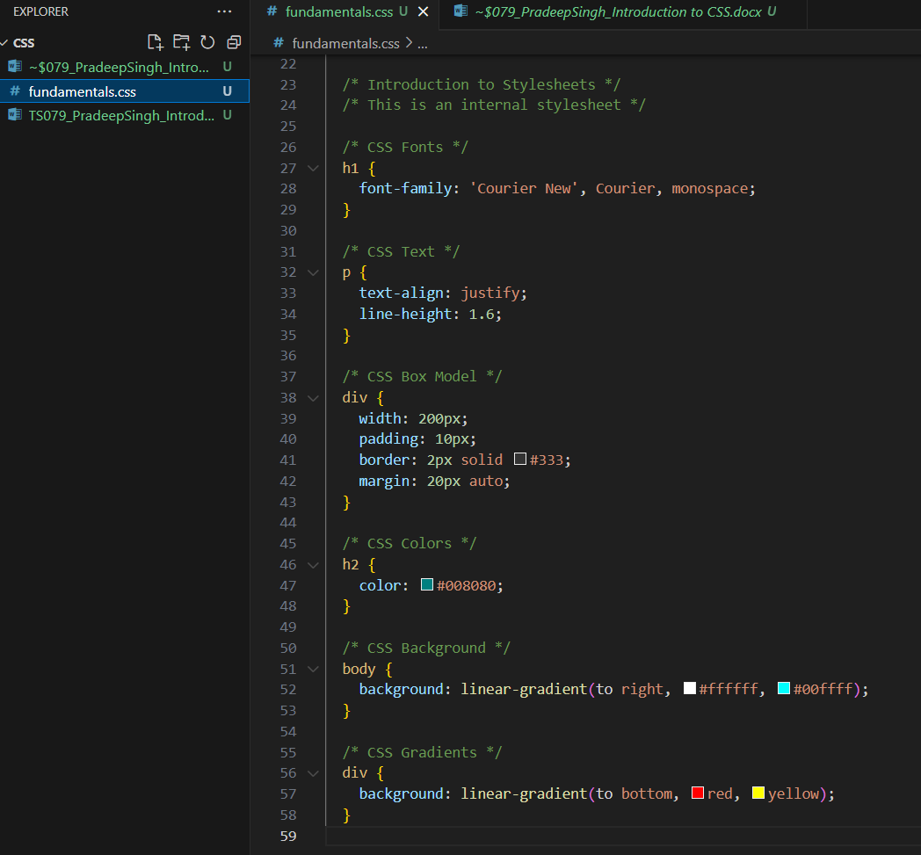



As we can se in above attached screenshot I have mentioned the syntax to use particular CSS just for learning purpose.